2026
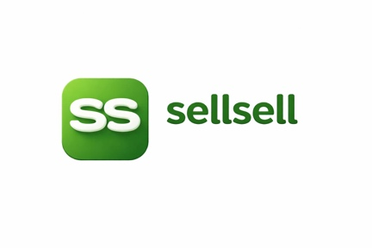
sellsell marketplace updates:

Shaz EJ

Overall Project Status
Area | Status
Marketplace Core | ✅ Complete
Seller Flow | ✅ Complete
Buyer AI Search | ✅ Complete
AI Listing Generation | ✅ Complete
AI Moderation Pipeline | ✅ Complete
Qdrant Semantic Search | ✅ Complete
PostgreSQL Integration | ✅ Complete
Redis Queue System | ✅ Complete
RunPod Ollama Integration | ✅ Complete
RunPod Transcription | ✅ Complete
Local Upload Storage | ✅ Complete
Production Upload Storage | ✅ Complete
Notification System | ✅ Developed
Seller Demand Capture | ✅ Developed
Admin Dashboard | ✅ Developed
ESLint Cleanup | ✅ Complete
TypeScript Cleanup | ✅ Complete
Playwright E2E Tests | ✅ Complete (21/21 passing)
Production Health Checks | ✅ Healthy
Docker Infrastructure | ✅ Stable

Completion Estimate

Core Marketplace MVP
98% Complete
The platform is already capable of:
- Seller uploads item
- AI generates listing
- AI moderates listing
- Listing publishes
- Embeddings generated
- Indexed into Qdrant
- Buyer searches naturally
- AI retrieves matching products
- Buyer contacts seller
- Seller receives notifications
- Seller sees market demand
- Admin monitors platform
This is already a usable marketplace.

Remaining Work

Priority 3 — Local Development Stability
Estimated: 30–60 minutes
Need a final audit:
- Redis
- PostgreSQL
- Qdrant
- RunPod tunnel
- Dev startup scripts
- Environment consistency

Priority 4 — Notifications QA
Estimated: 1–2 hours
Need to verify:
- Contact click notifications
- Chat notifications
- Demand match notifications
- Notification center
- Mobile badges
- Desktop badges
The code exists. This is primarily QA and verification.

Priority 5 — Backup System
Estimated: 1–2 hours
Need:
- PostgreSQL backup script
- Uploads backup script
- Qdrant backup
- Restore script
- Cron schedule
This is the biggest remaining infrastructure gap.

After That
Only three major items remain before launch:

1. Mobile App Polish
Current status:
- Mobile app exists
- Needs stabilization and UX polishing

2. Push Notifications
Need:
- Firebase (Android)
- APNS (iOS)
Current notifications are in-app only.

3. Production Load Testing
Need:
- 100 users
- 500 users
- 1000 users
Verify:
- PostgreSQL
- Redis
- Qdrant
- Ollama throughput

My Recommendation for Today
Since it is already around 01:30 AM:

Stop development tonight.
You have already completed:
- ESLint cleanup
- TypeScript cleanup
- E2E stabilization
- Production storage verification
- Health check verification
- Notifications implementation
- Admin dashboard implementation
Tomorrow morning:
- Local Environment Stability Audit
- Notifications QA
- Backup System
- Deploy any remaining fixes to production
- Begin mobile app polish
If those are completed tomorrow, the platform will realistically be 99% MVP complete and the remaining work becomes launch preparation rather than core development.

